Rock Paper Scissors – Extended Project Summary
Based on Project #59 from The Big Book of Small Python Projects by Al Sweigart

Problem Statement:
Implement the classic Rock-Paper-Scissors hand game against a computer opponent. The original program uses nested while-loops, input validation, a dramatic countdown with time.sleep, random computer moves, and a long if-elif chain for win/lose/tie logic. Extend it with: (1) Rock-Paper-Scissors-Lizard-Spock rules, (2) a clean dictionary-based win table as an alternate implementation, (3) a points / double-or-nothing scoring system, (4) best-of-N and always-win variants, and (5) a Monte-Carlo simulation section that lets the learner change parameters and observe different outcome distributions.

Solution Strategy:
1. Modularize into helpers (normalize input, computer move, outcome determination).
2. Provide two parallel win-logic implementations: BEATS dictionary (extensible) and pure if-elif (book style).
3. Keep a non-interactive play_round for Jupyter demos and a full interactive loop that matches the original source.
4. Add simulation harness with tunable N_GAMES, PLAYER_STRATEGY and MODE; visualize results with bar + pie charts.
5. Include flowchart of the complete control flow for both notebooks.

Solution:
Core files produced:
• Rock_Paper_Scissors_Practice_Skeleton.ipynb – step-by-step TODOs
• Rock_Paper_Scissors_Solution.ipynb – complete working code + demos
• rock_paper_scissors_flowchart.png – program flow diagram
• rock_paper_scissors_simulation.png – example Monte-Carlo results
Sample simulation (5 000 random classic games) converges to ≈ 33 % win / 33 % lose / 33 % tie, confirming fairness. Strategy comparison shows that always-rock, always-paper, random and cyclic strategies all yield the same long-run percentages against a uniform computer, as expected by symmetry.
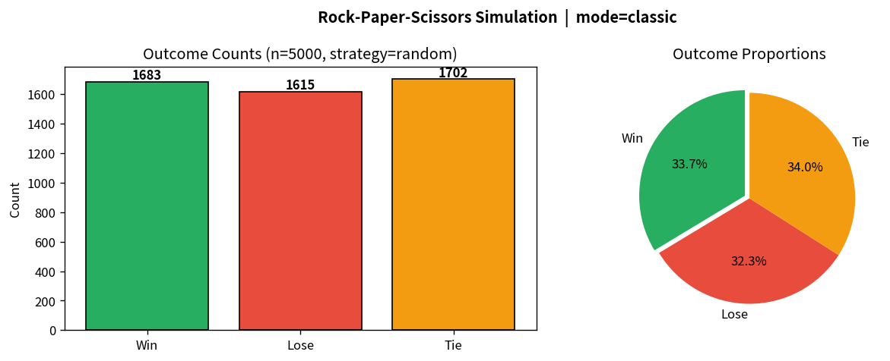

Key Takeaways:
• The original if-elif chain works but becomes brittle when adding Lizard & Spock; a BEATS dictionary scales cleanly.
• A few time.sleep calls dramatically improve perceived polish of a text game.
• Separating pure logic (determine_outcome) from I/O (play_round / interactive loop) enables easy testing and simulation.
• Monte-Carlo experiments quickly illustrate that no pure strategy beats a uniform random opponent in the long run.
• Extending a 85-line classic into RPSLS + points + best-of-N + simulation is a natural next step after mastering the book version.

